**Instructor Read Me File – Tableau for Beginners – Tableau Desktop Level 1 - Introduction**

**\*\*\*Please note. Tableau Desktop Levels 1, 2, 3, and the Data Visualization classes are all taught with a FREE 14 Day Trial of Tableau Desktop which needs to installed before class begins.**

**John Farnum has graciously contributed the instructions to do a quick install on the student’s computers. After these directions, please see the rest of the Read Me file for tips on where to find things, approximate lab timings and any suggestions for labs.**

**Enjoy your class!**

First Step: Install Tableau on Student Machines (Thank you John Farnum for your contribution on how to download tableau on all student computers at one time!)

1. To launch the Tableau Desktop Installer on all student workstations.
   1. Use NetAdminLookout and choose the **Tools** tab.
   2. Run Tableau Desktop installer located in the Downloads folder for each student.

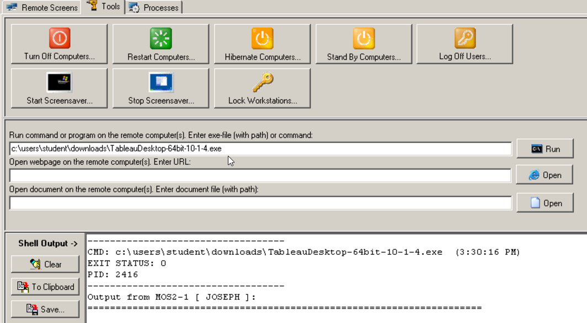

* 1. Command path(example): **C:\users\student\downloads\TableauDesktop-64bit-2018-1-0.exe**

1. Choose **Run** command button and select All.
2. 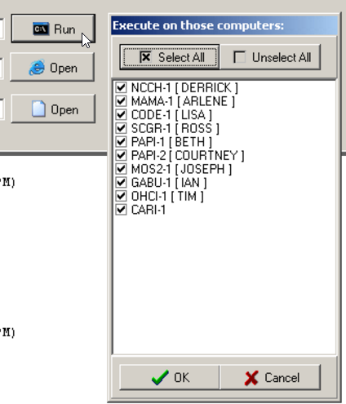
3. Tableau Installation will begin on all selected student workstations. Remote into each workstation and choose Install.

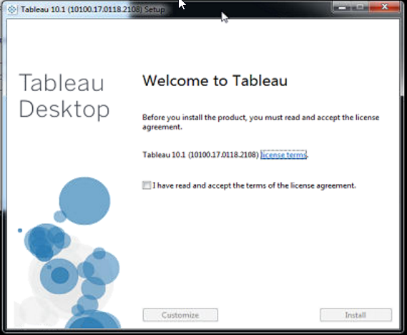

1. Once installer completes, **Tableau Registration** form appears.

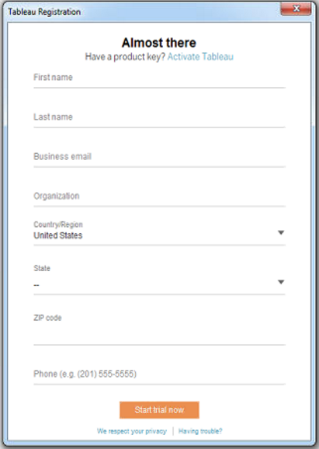

1. CANCEL/Close out of this registration and return to the Desktop.
2. Restart **Tableau Desktop** application from the Desktop icon and the **Tableau Registration** form re-appears.

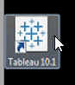

* 1. **Notice** how the registration form is now filled in with generic data from Tableau! All you need to supply is a series of numbers for a phone #. (Make it up)

|  |  |
| --- | --- |
|  |  |

1. Click **Start Trial Now**…and you are done! Tableau Desktop is now fully functional for 14-days and ready for your class.

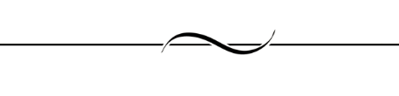

**Files for Class:**

**Excel Sample Superstore**

**\*\*\*\*Please note: Anytime the book refers to any version of Tableau, please inform the students that we are using 2018.1 – Therefore, the path to the EXCEL SAMPLE SUPERSTORE will be:**

**\My Tableau Repository\Datasources\2018.1\en_US-EU**

**ALL OTHER TABLEAU STUDENT FILES FOR CLASS WILL BE LOCATED ON THE DESKTOP ACCORDING TO THE NAME OF THE COURSE:**

**Tableau Desktop Level 1**

**Tableau Desktop Level 2]**

**Tableau Desktop Level 3**

**Tableau Data Visual Analytics**



**CHAPTER BY CHAPTER**

Page 11 in the book shows students how to download the files for this class. Be sure to bring them to this page, so after class is over, they can download for their personal use.

In the Tableau for Beginners class, there are THREE separate downloads:

1. Workbooks
2. A Preference File (which is used in Chapter 9, Formatting, for Custom XML colors)
3. Data Sources

These files are already in that folder. (in almost every case, the files represent the SOLUTIONS. This is because students either start with a NEW workbook or they are copying previous workbooks and “Saving as”.

After Class: Students Can Download Files from our GitHub Repository:

1. Go to: <https://github.com/ONLC-Classes/ONLC-Classes-ONLC-Classes-XTBI10---Tableau-Desktop-Level-1>
2. Click the Green “Clone or Download” button
3. Save to a local file



In every chapter, the students are given a “URL” to download the workbooks. Instead, they can use Page 11 to get them all. In class of course, we have already downloaded all the files. If you wish to, you can take the students to any URL in the book to demo them, but for sake of time, we suggest the just use the files in the folders provided.



Set the expectations on Day 1 during introductions. There are LOADS of “Hands On” Exercises in this class. Gauge your audience and determine how many you will let people do on their own vs. what you want to do with them. On Day 2, the students should have as much “Hands On” as possible.



Chapter 13 is on Tableau Server. Please just go through it quickly and explain that we offer a Tableau Server class if anyone is interested. The students should be “full” at this point and will appreciate you skimming through it!



**Day One – Chapters 1-6 (approximately):**

**\*\*Before you begin – There is a great deal of material in this book, even though it is small. Approximate lab and lecture/demo times are below. In order to finish, be sure to go through each set of labs.**

**Chapter 1 – INTRO (short and sweet, knowing you will dive into details throughout book)**

**Approximate time to take: 10 minutes.**

Chapter 1 of the Tableau for Beginners book is an overview only. In Tableau Desktop Level 1 folder (on the desktop), they gave the students a file, but it has nothing in it. This chapter length and demos can be gauged by the Instructor, depending on who is in the class.

This chapter should be breezed through, telling the students that details will follow in later chapters.

**Chapter 2 – Connecting to Data (excellent and includes several new options)**

**Approximate time to take: 30-40 minutes.**

**Discussion and Demo 10 minutes,**

**Lab Exercises 10-20 Minutes.**

The finished samples are ONLINE at: They have a sample workbook already done. You can see the sample “done” files here: <http://tabsoft.co/2ppD2Xf> These files can also be downloaded from that point!

Chapter 2 is an overview of the Tableau IDE. Chapter 2 has labs in it as well, but the students are building this from scratch. Although there is a starting file for Chapter 2 in the Workbooks downloads, it is empty. The students will build from “scratch”.

On page 24, their first exercise is to connect to the Excel Sample Superstore and end up on “Sheet 1”. Then, on Page 26, it shows the Tableau IDE with a chart in it. The students do not build this chart, but you should walk them through this simple drag and drop, just so their picture matches on Page 26.

Walk Through Fields to Use:

ORDER DATE to Column (discrete/blue) by Month (explanation of discrete and continuous coming up in two pages)

Profit Measure to Row

Segment to Color.

Segment to Filter: This is too early to go into filter “Details”. For now, just have them drag Segment into the Filter pane, so you can show them how to “show filter” (with the dropdown of Segment Pill in Filter. Also at this time, show them how to move the “Show Me” box out of the way by toggling it back and forth.

This will allow you to go over all the items on pages 27-32 – 10 minutes

**Page 33 – Using Visualizations to Answer Business Questions**

They have a sample workbook already done. It is located here : <http://tabsoft.co/2ppD2Xf> - TIMESAVER: Show them the picture at the bottom of page 33. This is the same chart as the link above. (if you want to go into Tableau Public at any time, you could demo this or have them see it in the browser – your choice)

You can just go there to demo to the students the completed workbooks. If you wish the students to go here also, you can, but it is not necessary.

The students will also be told to open the “Starter” workbook (Chapter2, but it is just as easy with them to continue on with the workbook they created.)

There is one quick lab at beginning (Pages 24 and 25 and if you want them to build with you page 26)

Then, the lab exercises go from pages 33-40. See below for details:

**Glitch:** Page 33 – have the students **DRAG** the fields, not double click. They want the chart on page 33 to match the directions.

**Glitch:** Page 37 – The Show me box shows everything BUT the Highlighted Table. Just tell them to play with the choices the Show Me gave them.

**Page 33 – Drill Downs Exercise – works as expected**

**Page 38 - Analytics Pane –**

Glitch: Page 39 doesn’t tell them what to name the sheet. They can call it “Analytics”. All else works as expected.

**Chapter 3 - Transforming Data (easier ways for students to customize data they have in Tableau)**

The finished VISUALIZATION files for this lab are empty, even though they give you the URL: <http://tabsoft.co/2pQO4WE>

**Estimated Timing: Lecture, Demos: 20-30 minutes.**

**Exercises 30-45 minutes depending on audience.**

However, when students open the Chapter 3 starter (on page 45), there are data files in the data tab. One is the excel sample superstore and you will also see another data source (shipper info.csv) in the data window.

Page 41-44 can be taught by book, demos, etc.

The exercises begin on Page 45 and are surprisingly good! The fact that they bring up data transformation at this point allows people to understand that Tableau can be customized. Also, the labs are concise and the students will enjoy them.

**Exercises:**

**Pages 45 –61 – Before you let the students loose on these pages, you should teach and demo everything on them quickly. Then let them go. They will enjoy the labs and learn A LOT from this easy but helpful set of exercises. –**

**\*\*It is best to have them start in one workbook (the first being “Data Transformation” and have them do all the exercises in this same workbook, adding worksheets and data sources as needed. The reason is that the only files they have in the workbook file are done already.**

**Transforming data in the Sample-Superstore data source – The students will create two hierarchies (one regarding “location” and one regarding “Products”. They also learn how to create a folder and aliases to customize their “Data Pane”**

**Glitch –** Page 46 – they tell the students how to make a folder and what should be in it, but students will need to drag the Customer Name field into the new folder.

**Glitch** – Page 47, add the words “click Extract” after the last direction on Step #8. Also the lab tells the students to look in data source folder for their new .tde. This will be in the same location they saved their last datasource.

**Glitch** – Page 49 – Second Paragraph. Technically, this is not a glitch, but rather a choice. Since this tableau image is being shared between 4 classes, the data sources will all be in the “Tableau Desktop Level 1 folder under the “Data Sources” folder. This will keep our images cleaner and easier to update. So be sure to tell the students to look in this folder for all data sources for this class.

**Glitch** – Page 53 – Introducing Data Blending. On page 53, you are introducing Data Blending to the students and maybe doing a demo. Be sure to open the workbook they have prepared for these pages. It is called “Data Blending”. If, for some reason, you kept the previous exercise open, when you demo, there will be no “Sales” field in the SalesReport.xlsx data fields. This is because in the previous exercise, you pivoted those fields. It is best to open the workbook called “OHT_Chapter3-DataBlending.twbx” for this demo. – If the students use this file however, the work will be done for them already in this small exercise. So, they may want to continue on with previous lab.

**Glitch - Pages 56-59 – Joins – if they continue in same workbook, they will have to “ADD” another data source here (which they have previously learned). If they open the one called “Joins”, they will get a message that asks if it is okay to open because joins are present. It is best for them to use same workbook they started with (as advised above).**

**Pages 60-61 – Work as expected and it’s so exciting we get to offer custom SQL Syntax!!**

**LUNCH**

**Chapter 4 – Calculations (book is great and emphasizes aggregates)**

The finished VISUALIZATION files for this lab have files in them, also, they are located at this URL: <http://tabsoft.co/2qmpTiE>

**Estimated Timing: Lecture, Demos: 30-40 minutes.**

**Exercises 45-60 minutes depending on audience.**

**You can either go from topic to topic, stopping to explain, then let the students do the lab OR you can go through entire chapter and then “let them loose” on exercises Pages 63-85 – this depends on audience. Also, you could do some “with the students” and let them loose on others.

**Glitch: On page 63, they have you “showing filter” for Region, City. They forgot to tell you to “show filter” for Order Date as well. Page 64 depicts this. Order date doesn’t really fall into the exercise, but to keep consistent with the book, they can add it.**

**Glitch: On Page 72, step #5, they have you place Running Sum of Profit (new calc) on Table. Place on top of PROFIT COLUMN**

**Glitch: Page 81, Top of page, has students “drag out” County and State off the view. We do not have County and State… ignore this.**

**Glitch: Page 82, Step #5, Drag “Profit by Order ID” to Column to get view on page 83.**

**Chapter 5 – More Calculations (Logical, Strings, Numbers and Dates)**

The finished VISUALIZATION files for this lab have files in them, also, they are located at this URL: <http://tabsoft.co/2qmpTiE>

**Estimated Timing: Lecture, Demos: 20-30 minutes.**

**Exercises 30-45 minutes depending on audience.**

Like the last chapter, you can either lecture and demo everything, then let students loose on labs, OR you can do a few at a time with them and let them loose on rest. Depending on your audience. – Suggestion – Page 91 (Floor and Ceiling function) – book is not clear. Either do this for students or with them.

**Each time they tell you to drag fields to the canvas or view and students are not sure, there will be a picture following. Get the students in the habit of looking at the pictures. Where there are no pictures, you will see a “glitch” in this read me.

Formatting/Default Properties is discussed this chapter on page 90. You will need to point out how the students should format decimal places and how default properties can keep things consistent in Tableau.

**Page 90-91 – Put ALL the fields into the ROW and use “show me” to get the table pictured on page 91.**

**THEN: Drag “Region” to Row (to the right of Category), THEN Drag “Profit for Region” to the Row, Next to “Region” – SEE THE NULLS.**

**THEN: Follow the directions in the middle of Page 91 to Edit the “Profit for Region” to include ZN of nulls.**

**THEN: Remove “Profit for Region” and replace with Profit for Region_ZN. Click Show Me and Click first table. NULLS replaced with ZEROS**

**Page 92 should look familiar. We created this exact function in a previous Tableau Class.**

**Chapter 6 – Filters and Parameters**

**FILTERS**

The finished VISUALIZATION files for this lab have files in them, also, they are located at this URL: <http://tabsoft.co/2qmH5Vh>

**FILTERS: Estimated Timing: Lecture, Demos: 10 minutes.**

**FILTERS: Exercises 15-20 minutes depending on audience.**

**FILTERS:**

**The concept of FILTERS in this chapter is really good. They first show filters on the Data Source which will then be reflected on any sheets created after this.**

**\*\*Remind students that filters and legends appear under the “Show Me”. They can toggle it by clicking or pressing CTRL + 1**

**Glitch: Page 100. At the end, it says that your chart will look like the one on page 101. Students may have to choose the “bar” chart on Show Me (depending on how they got the fields into the view – double click vs. drag, right drag, etc.)**

**Parameters**

There are NO files up on the URL for this portion: <http://tabsoft.co/2oZKhl6>

**PARAMETERS: Estimated Timing: Lecture, Demos: 10 minutes.**

**PARAMETERS: Exercises 15-20 minutes depending on audience.**

**PARAMETERS:**

Depending on your audience, you can choose to do these labs with the students or let them loose. This lab is awesome and simple for the students! A great way for them to end Day 1



**Day Two – Chapters 7-13**

**Chapter 7 – Sorting**

The finished VISUALIZATION files for this lab have files in them, also, they are located at this URL: <http://tabsoft.co/2p2Mtcl> (all the files are complete and can be used for demos if desired, instead of workbook solutions)

**Estimated Timing: Lecture, Demos: 10-15 minutes.**

**Exercises 10-15 minutes depending on audience.**

Labs are easy and straight forward. COMBINED fields are introduced here. Simple!

**Chapter 8 – GROUPS and SETS**

The finished VISUALIZATION files for this lab have files in them, also, they are located at this URL: <http://tabsoft.co/2qxM7e2> (all the files are complete and can be used for demos if desired, instead of workbook solutions)

**GROUPS**

**GROUPS: Estimated Timing: Lecture, Demos: 10 minutes.**

**GROUPS: Exercises 10 minutes depending on audience.**

**Glitch: Page 114 – BEFORE Step #4, have the students click on the BAR chart in Show Me AGAIN. Then they will see the separation of the group and the group move to rows as pointed out in book.**

**SETS**

**Estimated Timing: Lecture, Demos: 5 minutes.**

**Exercises 10 minutes depending on audience.**

**Glitch: Page 121 – AFTER students create the SET at the top of page 121, have students go to the Show Me and change to bar chart, before continuing exercise.**

**Chapter 9 – FORMATTING**

**IF YOU CAN FINISH BEFORE LUNCH, PERFECT.. IF NOT, TAKE LUNCH BEFORE YOU DO PAGES 134-rest of chapter. Read through and prep below info. With each class, this timing will vary. If you are running short on time, you can have EVERYONE copy and paste the preferences file, instead of giving an option to type it. Potentially, if you are REALLY running behind, you could copy and paste the file FOR them while they are at lunch or in the morning before you begin.**

The finished VISUALIZATION files for this lab have files in them, also, they are located at this URL: <http://tabsoft.co/2pzvYpe> (all the files are complete and can be used for demos if desired, instead of workbook solutions)

**Estimated Timing: Lecture, Demos: 20 minutes -**

**Exercises 10 minutes depending on audience.**

Pages 123-131 are exactly what you would expect for formatting.

THEN…. On Page 132, the book talks about customizing colors through Palettes. However, on Page 134, this book also talks about creating CUSTOM colors with XML. This is really good and the concept is that you are using “true” colors, which will look same on all browsers and all IoT (Internet of things or mobile devices).

The finished VISUALIZATION files for this lab have files in them, also, they are located at this URL: <http://tabsoft.co/2pzvYpe> (all the files are complete and can be used for demos if desired, instead of workbook solutions)

**Custom Colors and Highlighting: Estimated Timing: Lecture, Demos: 5-10 minutes -**

**Custom Colors and Highlighting: Exercises 20-30 minutes depending on audience and depending whether students type the XML or not.**

**Good Info: On page 135, the students will be working with an XML Preferences file. To make this go smoothly, approach it this way:**

1. **Have the students go to: documents, Tableau Repository and see the Preferences File (tps stands for Tableau Preferences File). Explain that these preferences are defaults that can customize and be set up for Tableau. Have them right click it, open it and see the default/empty one.**
2. **Of COURSE some students may want to type the XML on page 135. If they want to, allow them to… BUT – make sure that you go to the LAB files for the Level 1 class first and show them that there is a “Preferences_Modified.tps” file - They can right click and edit in notepad, so they can copy all the code from this file to the original. Or they can copy the entire file and change the name to “Preferences.tps”. The point is that they would not have to type the code.**
3. **The lab is excellent, but may not be for everyone “new” to Tableau. Feel free to SKIP it.**

**Next, on Page 138 the HIGHLIGHT lab is just easy peasy and nice for the students. Be sure to get the Show Me box out of the way to see this highlighter filter!**

**Chapter 10 – MAPS**

The finished VISUALIZATION files for this lab have files in them, also, they are located at this URL: <http://tabsoft.co/2p2SINj> (all the files are complete and can be used for demos if desired, instead of workbook solutions)

**Estimated Timing: Lecture, Demos: 20 minutes**

**Exercises 20 minutes depending on audience.**

**Glitch: TALK ONLY about pages 144-146. Unknown locations are getting to be a “thing of the past” when it comes to States. Our dataset is USA only. But, you can read through and show the students that IF they get some unknown locations, there is a wizard in Tableau that will try to fix these items.**

**Chapter 11 – Visualizations (all types of charts – FUN!)**

The finished VISUALIZATION files for this lab have files in them, also, they are located at this URL: <http://tabsoft.co/2oRLmQC> (all the files are complete and can be used for demos if desired, instead of workbook solutions)

**Estimated Timing: Lecture, Demos: 10 minutes – Just let students know they will get a bevy of experience creating visualizations. You will give a time frame and they will create as much as possible until then.**

**Exercises 45-60 minutes depending on audience and your time frame. If you are running late, give 30 minutes. – ALSO – you will need to demo the DONUT chart as it is confusing… See glitch below in case students have issues.**

**Good Info: Page 54 has the students typing in a calculation – please note that they can open the SOLUTION and copy and paste this calculation called “Sales Color” from the solution into their Workbook. – you should demo this for the students if possible.**

**Page 154 – you can demo or you can do this with the students. The point is “dual axis”. The directions are confusing. On page 155, Step #7 should be the FIRST Latitude changed to circles, NOT the second. The second should be a filled map. THEN, create less confusion by having the students “Edit the colors” on the filled map by dragging the opaque button to the left. This will leave muted colors so that the top chart’s “circles” will show up better.**

**Page 157 – They have you pick a Quick Table Calculation, but the picture in the book isn’t great. They should pick “Percent of Total” – Also, after the pie chart is done, change “standard view” to “entire view” to make pie chart bigger.**

**Glitch: Donut Chart – Page 158. Step #2, After they drag “Number of Records” onto the row, have them choose “Attribute” off the list. This size will be the best for this chart. Then after Step #7, have the students change to “Entire View” up in toolbar combo box.**

**Pages 160 and 162 – Bar Charts – Might need for students to use “SWAP” button to get the bars Vertical, instead of horizontal.**

**Glitch: Page 169 – After Step #3, they ask students to select options. Just have them click OK. They won’t be familiar with any options until they see what the reference line will be.**

**Chapter 12 – Dashboards**

The finished VISUALIZATION files for this lab have files in them, also, they are located at this URL: <http://tabsoft.co/2ppFixC> - (all the files are complete and can be used for demos if desired, instead of workbook solutions)

**Estimated Timing: Lecture, Demos: 20-30 minutes – You will need to explain the difference between Dashboards and Stories. Also, if you have extra time, you can introduce the other types of “actions” in the dashboard, other than filter.**

**Exercises 20-30 minutes depending on audience and your time frame.**

**Glitch: Page 180 – Step #2 – the charts should read: Heat Maps, Bars, Tables. Also, the SEGMENT filter is part of the HEAT MAPS chart, not the Bar/Combo chart. Also, the pull down menu they refer to in Step #3, is actually under the “Apply to Worksheets” menu.**

**Chapter 13 – Server Deployment**

Use this chapter to explain that we teach a SERVER class but ask them to remember that you talked about the different products in Tableau. This chapter should not take you more than 5 minutes to skim over, depending on questions.